How to Determine If I Have a Lead Service
Check your records. Have you completed maintenance on your service line? Do you know when your home was built? If your home is older than 1988 and has the original service line or plumbing, then your home may have a lead service line or a lead component.

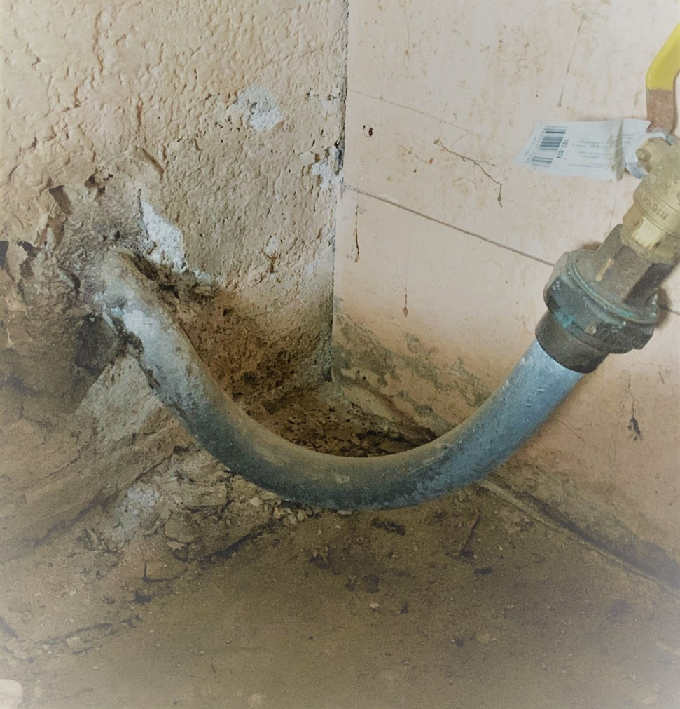
Photo of lead service line in home in North Platte, NE.

Inspect the service line yourself. You can save time and money and inspect the service line yourself. These lines typically enter your home through the wall facing the street on the lowest level but each setup can be unique to each home. If you do not own your home, please contact the homeowner for this information.
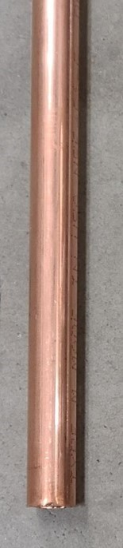
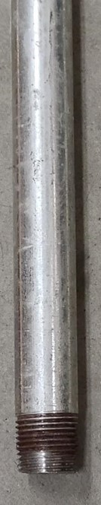
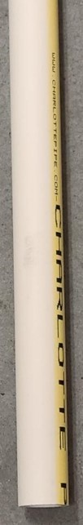
Is it Lead?
Start with a magnet or scratch test. Gently scratch the surface of the pipe with a coin. If the pipe is soft, easily scraped, silver, and a magnet doesn’t stick, it is most likely lead.

If Not Lead, Then What ?
- Does a magnet stick? If so and the line is dull grey when scratched, this portion of the service line is galvanized steel.
- If the magnet doesn't stick, it is same color as a penny when scratched or has greenish blue build up, this portion of the service line is copper.
- If the magnet doesn't stick, it is white-ish yellow or grey, is joined with a clamp, screw or glue, this portion of the service line is plastic or Chlorinated polyvinyl chloride (CPVC). Some other plastic pipes could be black or blue in color.
If you are still unsure about the materials present and have questions contact Cass County RWD #1 at 402-235-3077.
______________________________

Sources: EPA.gov, Lead Service Line Replacement Collaborative, “How Can I Find Out If I Have a Lead Service Line?” Betanzo, 2020.

